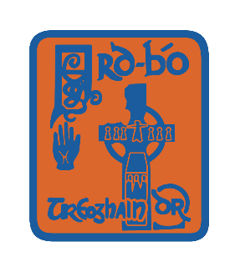

Ard Bó Uí Dhonnabhaín Rossa C.L.G

AGM 2014

**AINMHIÚCHAIN**

(NOMINATIONS)

|  |  |  |
| --- | --- | --- |
| Position | Outgoing | Nomination |
| Cathaoirleach:  (Chairperson) | Cathal Forbes |  |
| Rúnaí:  (Secretary) | Paul Teague |  |
| Cisteoir:  (Treasurer) | Enda Teague |  |
| Leas-Cathaoirleach:  (Vice Chairperson) | Lisa Mallaghan |  |
| Leas-Rúnaí:  (Assistant Secretary) | Claire Muldoon |  |
| Leas-Cisteoir:  (Assistant Treasurer) | Gerry V Forbes |  |
| Oifigeach Oiliúna:  (Coaching Officer) | Niall Muldoon |  |
| Oifigeach Caidreamh Poiblí:  (Public Relations Officer) | Brian Lavery |  |
| Ionadaí Contae:  (County Representative) | Gerry V Forbes |  |
| Oifigeach Cultur & Teanga:  (Culture & Language Officer) | Caoimhe Hurl |  |
| Oifigeach Árachais:  (Insurance Officer) | Kathleen Duffy |  |
| An Cláraitheoir:  (Registrar) | Gabriel Loughran |  |
| Oifigeach Leanaí  (Children’s Officer) | Louise Doherty |  |
| Na Coisteoirí:  (Committee Members) | John Devlin  Paddy Leonard  Paul Canavan  Eleanor Mallaghan  Barry Hagan  James McErlean  Benny Hurl  Noel O Neill  Karla Coney |  |

**NA RÚIN**

(MOTIONS)

Siníthe:_______________________________________ Dáta:__________