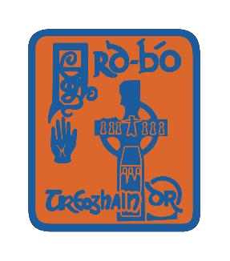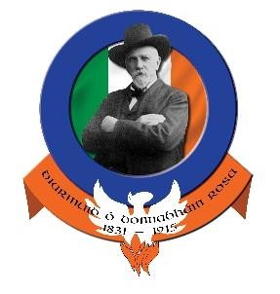

**The Following People have been nominated for positions in the committee of**

**Cumann Luthchleas Gael Úi Dhonnabháin Rosa Ardbό 2017**

**Chairperson: Patrick O Neill, Malachy O Neill, Kieran Devlin, Benny Hurl**

**Secretary: Karla McKinless**

**Treasurer: Brendan Wylie**

**Vice Chairperson: Cathal Forbes, Malachy O Neill**

**Ass Secretary: Paul Canavan, Collette Quinn**

**Ass Treasurer: Enda Teague**

**PRO: Lisa Mallaghan**

**Development Officer: Cathal McKeown, Noel O Neill, Paul Coney**

**Insurance Officer: Dermot Vallely**

**Motions For 2016 AGM**

**No.1 Ardboe GAC is currently represented by two main crests, the recent ‘ODR’ crest and the more traditional ‘Ardboe Old Cross’ crest. Going forward Ardboe should be represented by only the traditional old cross crest on all playing jerseys, Training Gear,Merchandise and assiociated marketing products**

**No.2 Gaelic Start to be renamed Rosa Óg**

**No.3 Under 20/21 Coaching Team to incorporate Representative Coaches from U-18’s,Reserve and Senior Coaching Teams. This is to assist in Development of players from youth to senior**

**No.4 Health and Wellbeing Officer to be appointed within the club**

**No.5 Following our club development plan 2014-2020 we should work towards a new committee structure which aims to share the workload and have an equal & inclusive representation through its sub committees. In taking the first steps we restructure our club committee for 2017 and beyond to include club executive officers plus a maximum of 5 committee members**

**No.6 That the club develop a sponsorship policy for all teams across the board**

**No.7 The club develop a policy and adhere to same in relation to playing and merchandise consistent with official guide**

**No.8 Ladies Membership to be paid by 31st march each year the same as the rest of us, we’re the one club so one rule for all**

**No,9 All Teams on Match Days from youth to senior both boys and girls should be wearing only club gear and club colours**